**Assignment 2**

**COMSATS University Islamabad**

Sahiwal Campus



**Usama Sarwar**

FA17-BS(CS)-090-B

**Mr. Yawar Abid**

Automata Theory (CSC312)

June 19, 2020

# Give DFA for the following languages, over the alphabet {0, 1}

## Set of all strings containing the substring 0110

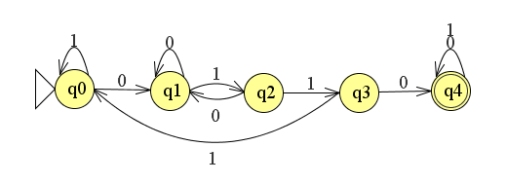

## Set of all strings that do not contain the substring 1010

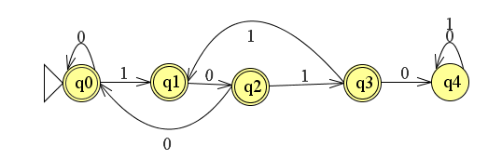

## Set of all strings that are exactly of length 5

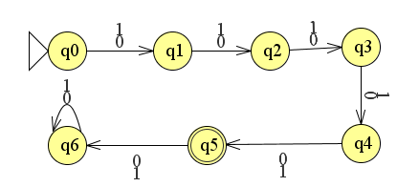

## Set of all strings that are at least of length 4 and contains even number of 1’s

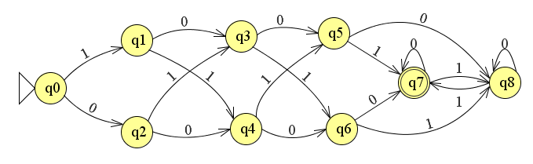

## Set of strings that either begin or end (or both) with 01

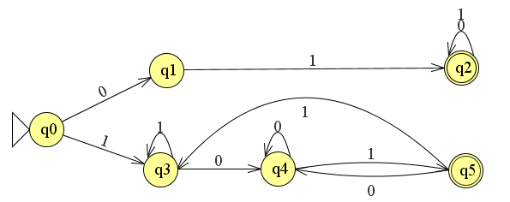

## Set of all strings with number of 0’s in multiples of 5 and number of 1’s in multiple of 3

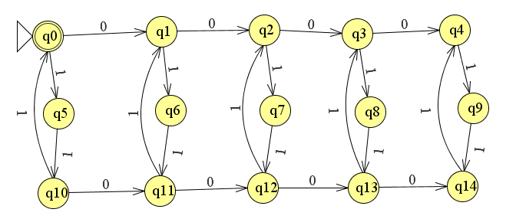

# Give DFA for the following languages, over the alphabet {a, b}

## {w| w has at least three a’s}

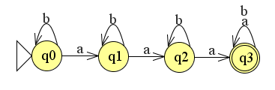

## {w| w has at least three a’s and at least two b’s}

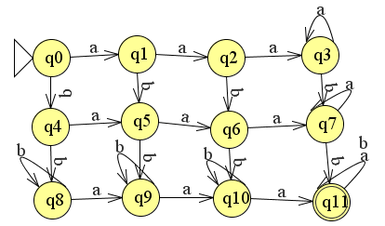

## {w| w has exactly two a’s and at least two b’s}



## {w| w has an even number of a’s}

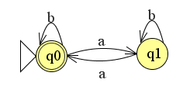

## {w| w has an even number of a’s and one or two b’s}

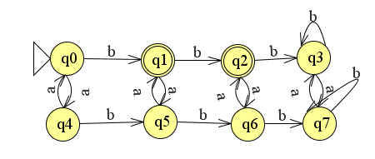

## {w| w has an even number of a’s and each a is followed by at least one b}

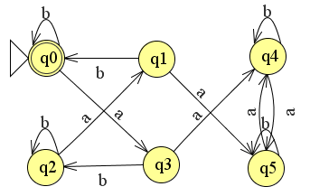

## {w| w has an odd number of a’s and ends with a b}

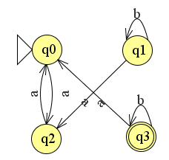

## {w| w has even length and an odd number of a’s}

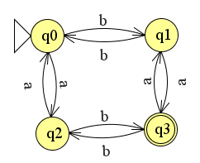

## All strings that do not end with aa.

